BIOCOMPUTING DESIGN PROJECT FMRI NONLINEAR ADAPTIVE NOISE FILTER FOR FUNCTIONAL TIME SERIES

Graphical User Interface Design Documents
Prepared for: Diksha Ghandi and Nikhil Tomy
Teaching Assistant: Robert Cooper
Alexander Matusiak
Cassandra North

5/1/12

REVISION HISTORY
Rev | Date | Revised By | Revision Notes
1 | 04/29/12 | Cassie North | Document Creation
2 | 04/30/12 | Cassie North | Updates to User/System Characteristics and GUI Design
3 | 04/30/12 | Alexander Matusiak | Updates to GUI Design, Test Plan and Training Sections
4

INTRODUCTION

  - PURPOSE
The purpose of the following document is to describe the requirements and specifications for a graphical user interface (GUI) developed as a tool for use of a non-linear adaptive noise filter applied to all voxel time series in a single functional run. The GUI is a C# tool which lies on top of a C implementation of this filter, developed as a separate effort. This document will also provide a test plan, results, and a user’s guide.
  - SCOPE
This document covers the graphical user interface design specifications for creating and displaying FMRI data before and after application of a non-linear adaptive noise filter. It will also provide a test plan and results as well as training documentation for use of the software.
  - TERMS AND DEFINITIONS
Term | Definition
MR | Magnetic Resonance Imaging
FMRI | Functional Magnetic Resonance Imaging
GUI | Graphical User Interface

USER AND SYSTEM CHARACTERISTICS

  - USER PROFILE
    - The user will be a human of average intelligence without major disability
    - The user will have limited knowledge of working with command line interfaces
    - The user will be capable of manipulating a mouse and keyboard
    - The user will have sufficient knowledge of the application of time series filtering, especially its implications for FMRI data.
  - SYSTEM CHARACTERISTICS
    - The system shall be compatible with Windows Vista and later versions.
    - The system shall not use command line input.
    - The system shall be composed of a single window.
    - The system shall utilize mouse click events.
    - The system shall utilize keyboard input.
    - The system shall rely upon the file system present on the current computer.
    - The system shall use color to distinguish between lines in a graph.

GUI DESIGN

  - UI PROTOTYPE
The figure below shows our initial design for the user interface. It includes a single window from which the user can select various parameters prior to applying the filter to the input data. It also includes two graphs which will display the before and after pictures of the time series data.
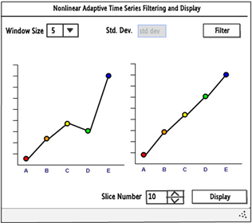

  - FINAL DESIGN
The following figure shows our final C# design. As you can see, the major modification that we made was in combining the before and after graphs. Prior to choosing a graphing library to use, we were unsure if this would be a possibility. A drop down list provides options for the neighborhood size, while a text box allows the user to choose their standard deviation. The Convert button will begin the time series filtering. The Get Slice button will then show the user the two graphs corresponding to an input and output file at the slice selected by the counter.
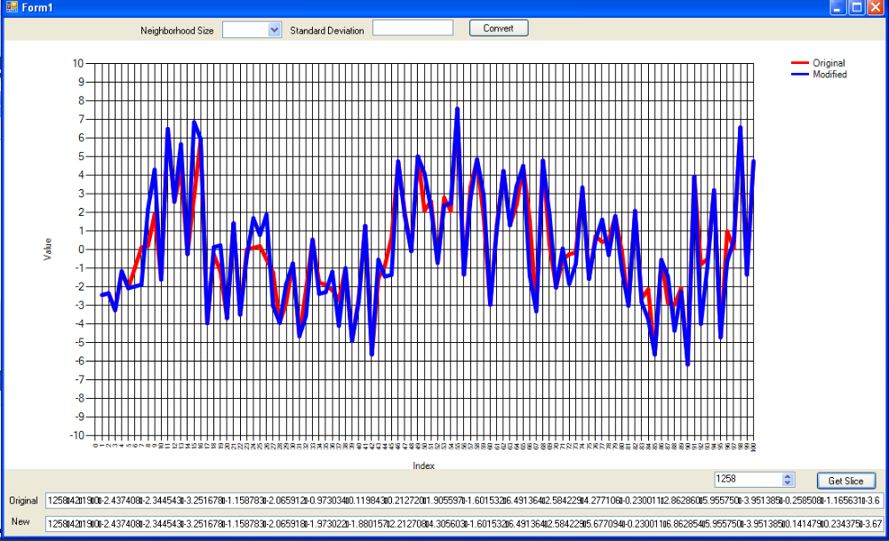

TEST PLAN AND RESULTS

  - UI GOALS
The following goals define metrics which our team must meet in the development of this GUI. The implementation of the GUI can be considered minimally acceptable if and only if all of these goals are met.
      - The user interface needs to require the least amount of clicks as possible.
      - User input in the program should be constrained as much as possible.
      - User should be notified the image processing algorithm thread has started.
      - User should be notified the image processing algorithm thread has stopped.
      - User should see a progress bar visualizing process execution.
      - The UI should remain responsive throughout process execution.
      - Once process execution has been stopped, the progress bar should disappear.
      - The UI should be disabled throughout process execution.
      - User should be allowed to choose input data files, standard deviation, and window for processing algorithm.
      - User should be allowed to choose input and output data files for displaying data.
      - Data should be displayed using an XY plot.
  - TEST PLAN AND RESULTS
The table below describes a list of test cases which were run on the implemented GUI in order to test its ease of use and ease of learning. This test plan follows directly from the goals described above. Also provided in this table are the results from each test case.
Test Case ID | Test Case Name | Summary | Results | Remarks
9.01 | Number of Clicks | Determine if the least amount of clicks possible has been used. | Pass | The only improvement in reducing click number would be to remove Message Boxes. Message Boxes however notify the user of important events, making it unwise to remove them.
9.02 | User Input | Constrain user input as much as possible. | Pass | The only variable input that has not been constrained is the standard deviation. Users may want to enter decimal point numbers, making it unwise to control this field too tightly. A dropdown list, counter, and file dialog boxes control the rest of the user's input.
9.03 | Process Start | User should be notified the image process has started. | Pass | A message box is used to inform the user the process has begun.
9.04 | Process Stop | User should be notified the image process has ended. | Pass | A message box is used to inform the user the process has stopped.
9.05 | UI responsiveness | The UI should remain responsive throughout process execution. | Pass | The UI remains responsive throughout execution thanks to a background thread. A delegate is used to pass arguments to the background worker DoWork() event.
9.06 | UI Process Feedback | The user should see a progress bar during process execution. | Pass
9.07 | UI Process Cleaning | After process execution has ended, the progress bar should disappear. | Pass | The RunWorkerCompleted() event hides the progress bar.
9.08 | UI Disabled | The UI should be disabled throughout process execution. | Pass | The main thread disables the GUI upon initializing the background worker. The RunWorkerCompleted() event re-enables the UI.
9.09 | Process I/O | The user should be able to select the input file, standard deviation, and window. | Pass
9.10 | Data I/O | The user should be able to select the input and output files to be displayed. | Pass
9.11 | Data Display | The data should be displayed in an XY plot. | Pass

TRAINING AND DOCUMENTATION

  - DEFINITION
The documentation for training someone to use this software will take the form of a user’s manual or guide. This guide will provide a walkthrough of the various components of the GUI as well as screenshots for further clarification.
  - USER’S MANUAL
The program regarding non-linear adaptive filtering has two main functions. The first is designed to start a non-linear adaptive filter that will process a data set. This functionality is controlled with the “Convert” button on the top of the screen. The user needs to set the desired standard deviation and window size before proceeding. The window size may only be the values selected from the dropdown list; where as the standard deviation can be any positive numeric value. Upon clicking the “Convert” button, a file dialog box will appear. Choose the appropriate input file to be used. Once the required parameters are collected, a message box will appear showing the user that the process has started. Be sure to click ok on the message box, otherwise the process will not in fact start. Due to threading issues, the user must be informed of the process starting before proceeding. A progress bar will increment and decrement informing the user that the application is processing the file. Upon completion of the process, the progress bar will disappear and the user shall be presented with another message box.
The second functionality regards displaying time series data by an XY plot. This is controlled by the counter and button on the lower half of the screen. Set the counter to the appropriate data index, and click “Get Slice”. A message box should appear informing the user to select the proper original input file. Upon clicking ok in the message box, a file dialog box should appear. Please select the original input file. Then, another message box should appear informing the user to select the appropriate processed file. Upon clicking ok in the message box, a file dialog box should appear. Please select the processed output file. The program will then retrieve the two data sets and displayed the original and processed time series.

